
Expressing as an entire surd

1 Complete the following. (The first one has been done for you.)
(a) 5 = 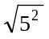 = 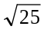 | (b) 7 = 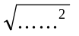 = 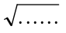 | (c) 11 = =
(d) 8 = = | (e) 15 = = | (f) 25 = =
Entire surds
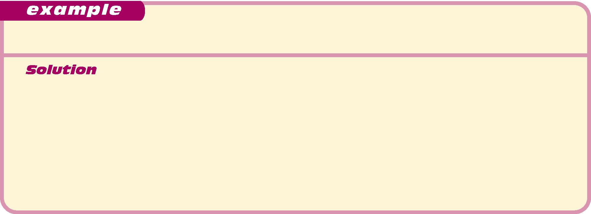
Express 3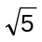 as an entire surd.
This needs to be turned into a surd so that the only numbers present are surds.

3 = 3 ×
= 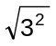 ×
= 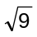 ×
= 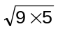
= 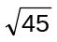 [this is called an entire surd]

2 Fill the gaps to express each of the following as an entire surd.
(a) 7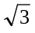 = 7 × 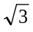  = ×  = 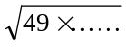  = 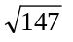 | (b) 5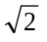 = …… ×  = ×  = 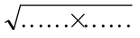  = | (c) 8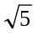 = …… ×  = ×  =  =
(d) 4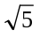 = …… ×  = ×  =  = | (e) 6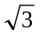 = …… ×  = ×  =  = | (f) 5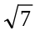 = …… ×  = ×  =  =
(g) 2 = …… ×  = ×  =  = | (h) 11 = …… ×  = ×  =  = | (i) 10 = …… ×  = ×  =  =

Expressing as an entire surd
Answers

1 (b) 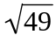 (c) 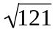 (d) 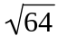 (e) 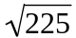 (f) 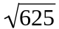
2 (b) 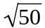 (c) 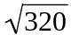 (d) 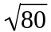 (e) 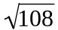 (f) 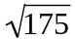 (g) 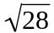 (h) 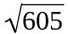 (i) 